Regulatory Principles Directive
RPDIR — 3
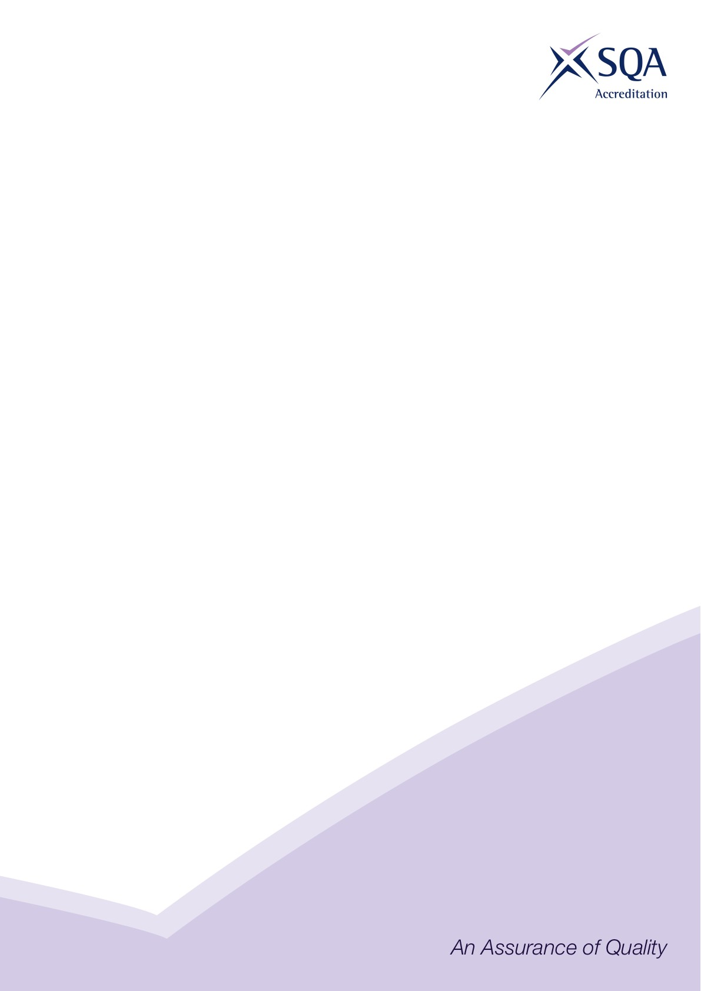

Logos and certificate requirements for SQA accredited qualifications


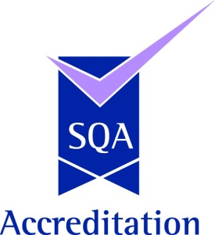
SVQ logo

The Scottish Vocational Qualification (SVQ) logo must be used on a certificate for the commemorative SVQ. Only Awarding Bodies that are approved by SQA Accreditation to offer SVQs are entitled to use the logo.

The SVQ logo must not be used on Unit certificates.

SQA Accreditation logo

All non-SVQ Awarding Bodies must use the SQA Accreditation logo. Only Awarding Bodies that are approved by SQA Accreditation are entitled to use the logo.

Where an Awarding Body is offering SVQs, the SVQ logo must be used, however, the Awarding Body may also use the SQA Accreditation logo as a second logo.

The SQA Accreditation logo may be used on Unit certificates.

SCQF logo

The SCQF logo can be used on any certificate where the qualification has been credit rated by a recognised Credit Rating Body or where the credit rating of the qualification has been approved by SQA’s Accreditation Co-ordination Group (ACG).

The SCQF logo may be used in conjunction with both the
SVQ logo and SQA Accreditation logo.

The SCQF logo may be used on Unit certificates.

Promotional use of logos

Approved Awarding Bodies are advised to check with SQA Accreditation prior to using the above logos for marketing and promotional purposes.

Please note that none of the above logos can be used by Awarding Bodies on centre approval certificates used to indicate when centre approval was granted.

SQA Accreditation has produced ‘Brand Identity Specifications’ for the SVQ, SQA Accreditation and SCQF logos. These contain information such as colour palettes and minimum sizes. Approved Awarding Bodies can request these through their appointed Regulation Manager.

Certificate requirements

Certificates must include the following information:

- The title of the qualification in the format agreed at the time of accreditation.
- The SQA Accreditation qualification code (4+2) issued at the time of accreditation.
- The Awarding Body logo (or logos where the Awarding Body is in a partnership).
- The full name of the Awarding Body (or the Awarding Body’s trading name) and authorised signatory (or signatories where the awarding body is in partnership).
- The date of issue of the certificate.
- Use of the relevant SVQ, SQA Accreditation and SCQF logos as described above.
- The SCQF level of the SVQ or qualification where it has been credit rated in line with current titling convention. SVQ Awarding Bodies may also show the overall credit value, however, this is not mandatory.

Where the qualification has been credit rated, a statement must also be included on the certificate to acknowledge the credit rating body.

Where non-SVQs have been credit rated, it is recommended that the Awarding Body shows the SCQF level and credit value however this is not mandatory.

It is not permitted for certificates to include centre names, co-branding logos or logos from other organisations, professional bodies and SSCs unless these organisations are in partnership to award the qualification.

Emergency First Aid at Work (EFAW) and First Aid at Work (FAW) certificates

Approved Bodies offering EFAW and FAW qualifications must ensure certificates also contain the following information:

- The title ‘Emergency First Aid at Work’ or ‘First Aid at Work’ as applicable
- Reference to the Health and Safety (First-Aid) Regulations 1981
- Confirmation that the certificate is valid for three years from the date of issue

General

Awarding Bodies are permitted to use their own wording on certificates, incorporate security enhancements such as barcodes or holographs and use unique candidate identification numbers.
For further advice and guidance on the use of logos and certificates, please refer to the certificate exemplars on the SQA Accreditation website or contact your appointed Regulation Manager.

This document is published by SQA Accreditation
For further information, please contact:
SQA Accreditation Officer: accredquals@sqa.org.uk 58 Robertson Street
SQA Accreditation www.sqa.org.uk/sqa/42159.html Glasgow
Tel: 0845 213 5259 G2 8DQ


SCQF Credit rated SVQs

1 Information and logos in bold are mandatory.
2 Information and logos in shade are optional.
3 Logos and text fields may be positioned in any location.
4 Awarding bodies may use their own individual wording.
5 Centre names are not permitted.
6 Partnerships may have additional logos and signatures.
7 The footer statement may only be used where the qualification
has been credit rated by a Credit Rating Body.
8 Contact SQA Accreditation for the SVQ, SQA Accreditation
and SCQF logo ‘Brand Identity Requirements’

This is to certify that

Candidate Name

has been awarded the

SVQ X in Accredited Award Title
at SCQF level X

Qualification Code: (4+2 code assigned at accreditation)

Date of issue:

Certificate Number:

SCN/Unique learner number:


Signatory’s position

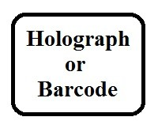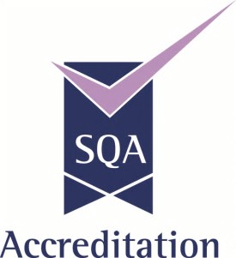

The above qualification has been credit rated by the Sample Credit Rating Body.

Non-SVQ qualifications

1 Information and logos in bold are mandatory.
2 Information and logos in shade are optional.
3 Logos and text fields may be positioned in any location.
4 Awarding bodies may use their own individual wording.
5 Centre names are not permitted.
6 Partnerships may have additional logos and signatures.
7 The footer statement may only be used where the qualification
has been credit rated by a Credit Rating Body.
8 Contact SQA Accreditation for the SVQ, SQA Accreditation
and SCQF logo ‘Brand Identity Requirements’.

This is to certify that

Candidate Name

has been awarded the

Accredited Award Title
(SCQF level if in the accredited title)

Qualification Code: (4+2 code assigned at accreditation)

Date of issue:

Certificate Number: Date of award:

SCN/Unique learner number: Expiry Date:

Signatory’s position

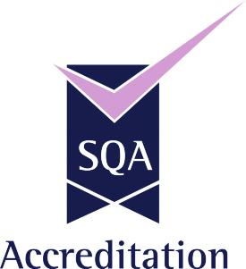

The above qualification has been credit rated by the Sample Credit Rating Body.
Sample credit rated Unit certificate
1 Information and logos in bold are mandatory.
2 Information and logos in shade are optional.
3 Logos and text fields may be positioned in any location.
4 Awarding bodies may choose their own individual wording.
5 Centre names are not permitted.
6 Partnerships may have additional logos and signatures.
7 Where the Units have been allocated a 4+2 code at the time of
Accreditation these should be used.
8 Where the awarding body is unable to show credit and level on its Unit
certificate a separate transcript must be used.
9 The SVQ logo must not be used on Unit certificates.
10 The footer statement may only be used where the Units have been credit
rated by a Credit Rating Body.
11 Contact SQA Accreditation for the SQA Accreditation and SCQF logo
‘Brand Identity Specifications’.

Certificate of Unit Credit

This is to certify that

Candidate Name

has achieved the following Units

Unit Code Unit Title SCQF level SCQF Credit Date achieved
XXXX XX Sample Unit Title 7 12 26.01.2012
XXXX XX Sample Unit Title 8 9 17.11.2011
XXXX XX Sample Unit Title 8 14 03.03.2011
XXXX XX Sample Unit Title 6 8 25.05.2011
XXXX XX Sample Unit Title n/a n/a 25.05.2011
XXXX XX Sample Unit Title 8 10 25.05.2011

Date of issue:
Certificate Number:
SCN/Unique learner number:
Signatory’s position

The above Units have been credit rated by the Sample Credit Rating Body.

