Quarterly Statistics Report
Highlights for Quarter 4 2021–22:
1 January – 31 March 2022

Publication date: May 2022
Publication code:

Published by the Scottish Qualifications Authority SQA Accreditation
The Optima Building, 58 Robertson Street, Glasgow, G2 8DQ Lowden, 24 Wester Shawfair, Dalkeith, Midlothian EH22 1FD

https://accreditation.sqa.org.uk

The information in this publication may be reproduced in support of SQA qualifications. If it is reproduced, SQA should be clearly acknowledged as the source. If it is to be used for any other purpose, then written permission must be obtained from SQA. It must not be reproduced for trade or commercial purposes.

© Scottish Qualifications Authority 2022

Contents
Summary 1
Data submissions 1
SVQs 2
1 Introduction 4
Methodology 4
2 Accredited qualifications 5
2.1 Total candidate registrations and certifications 6
2.1.1 Registrations 6
2.1.2 Certifications 6
2.2 Top ten qualifications 6
2.3 Registrations and certifications by qualification type 8
2.3.1 SVQs 8
2.3.2 Regulatory & Licensing (R&L) 9
2.3.3 ‘Other’ qualifications 9
2.4 Analysis by awarding body 10
2.4.1 SVQs 11
2.4.2 Regulatory and Licensing 11
2.4.3 Other’ qualifications 12
2.5 Analysis by developer 12
2.5.1 SVQs 13
2.5.2 Regulatory and Licensing 14
2.5.3 ‘Other’ qualifications 14
2.6 Analysis by qualification categories 15
3 Workplace Core Skills 17

Summary
This report provides statistical information on SQA Accreditation approved qualifications for the fourth quarter (Q4) of 2021–22 (1 January – 31 March 2022). This data is submitted by awarding bodies, who are responsible for quality assuring their data submissions.

At the end of this period there were 774 accredited qualifications: 446 Scottish Vocational Qualifications (SVQs), 22 Regulatory and Licensing qualifications, and 306 ‘Other’ qualifications.
In Q4 2021–22 there were 774 accredited qualifications, compared to 854 in Q4 of 2018–19.

Data submissions
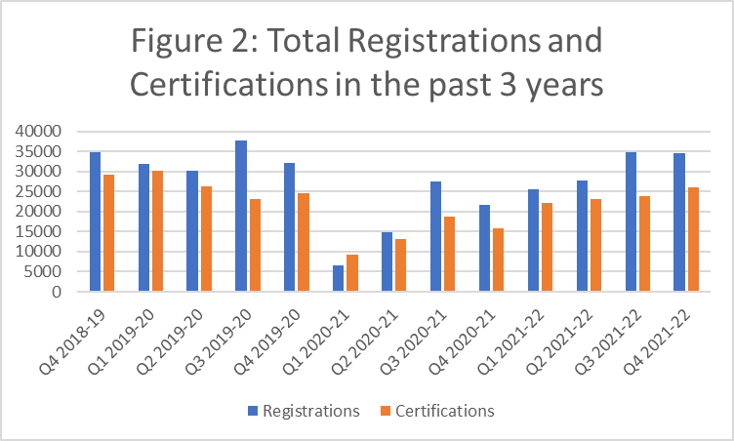
There were a total of 34,636* registrations (decrease of 0.2% from Q3) and 26,132* certifications (increase of 9.9% from Q3) in Q4.
*These totals do not include workplace core skills.

SVQs
Of these totals, 10,116 (29.2%) were SVQ registrations and 6,531 (24.9%) were SVQ certifications. The SQA awarding body had the highest percentage of SVQ registrations (89.6%) and certifications (85%). The developer with the highest proportion of SVQ registrations and certifications was Skills for Care and Development — 32.2 % and 31.8%, respectively.

Regulatory & Licensing qualifications
There were 3,835 registrations and 3,541 certifications, an increase of 22.3% and 19.9% respectively compared to Q3. Highfield Qualifications accounted for 54.2% of registrations and 55.6% of certifications. The developer with the most registrations and certifications was Scottish Government — 51.2% and 53.7% respectively.

‘Other’ qualifications
There were 20,785 registrations and 16,060 certifications, an increase of 9.3% in registrations and 9% increase in certifications compared to Q3. National Examination Board in Occupational Safety and Health (NEBOSH) accounted for 21.2% of registrations, First Aid Awards Limited (FAA) had the highest number of certifications – 26.2%. The developer with the largest proportion of registrations and certifications was First Aid Awarding Organisation Forum — 40.4% of registrations 50.9% of certifications.

Qualification category
The area with the highest number of registrations and certifications is 003 Health Care, Social Care and Childcare, as it was in Q3.

Workplace Core Skills
There were a total of 8787 registrations (a decrease of 3.2% compared to Q3) and 6597 certifications (a decrease of 14.9% compared to Q3).

1 Introduction
SQA Accreditation is the national accrediting body for Scotland with a statutory remit under the Education (Scotland) Act 1996 to accredit and quality assure qualifications in Scotland. Although part of the Scottish Qualifications Authority, SQA Accreditation is distinct and autonomous from SQA’s awarding function.
SQA Accreditation sets and specifies the requirements for accrediting qualifications to safeguard and support the interests of learners, parents, funding bodies, employers, providers and Scottish Government. We do this to promote and maintain public confidence in accredited qualifications and approved awarding bodies.

Methodology
This report summarises the qualification data that has been provided to us by approved awarding bodies, referred to as data submissions. Awarding bodies use a data submission template so all submissions are standardised. Registration and certification data is provided directly to SQA Accreditation, further information on the methodology can be found in our methodology document. This information covers SQA accredited qualifications during the fourth quarter (Q4) of 2021–22 (1 January – 31 March 2022) and shows the number of candidates who were:
- registered for an SQA accredited qualification
- certificated for an SQA accredited qualification
The data has been analysed in relation to:
- qualification type
- awarding body
- developer
- qualification category (classification)
- Workplace Core Skills
This document is published alongside the raw data received from the awarding bodies. If there are any figures below 10 then these are removed to protect confidentiality and represented by*. The numbers do not necessarily represent the number of learners, as a learner could register for several qualifications and could have achieved several certifications. The statistical information in this report is only collated by SQA Accreditation.
For upcoming data submissions, the following deadline dates apply and must be adhered to by all awarding bodies to ensure consistency and accuracy of data in future reports, the guidance document can be used to clarify how data must be submitted:
Quarter | Submission deadline
Quarter 1 (1 April – 30 June 2022) | 14 July 2022
Quarter 2 (1 July – 30 September 2022) | 14 October 2022
Quarter 3 (1 October – 31 December 2022) | 17 January 2023
Quarter 4 (1 January – 31 March 2023) | 14 April 2023

2 Accredited qualifications
At the end of Q4 of 2021–22 there were 774 live accredited qualifications.*
- 446 SVQs (57.6%)
- 22 Regulatory and Licensing qualifications (2.8%)
- 306 ‘Other’ qualifications (39.5%)
*Note that this total does not include qualifications that are within their lapsing period.
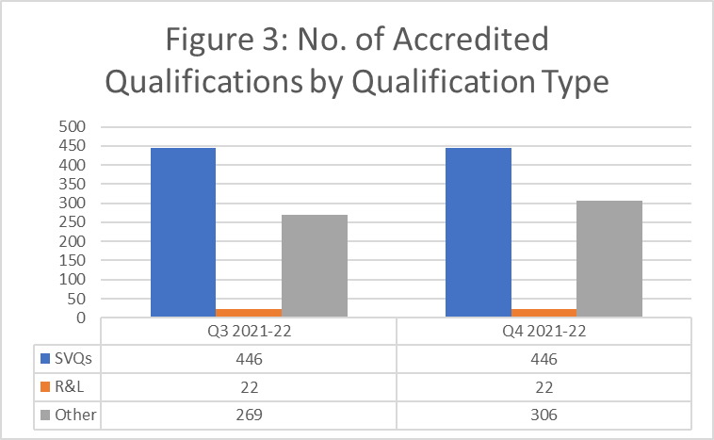
Compared to Q3, the total number of accredited qualifications has increased by 37. In Q4 2021–22 there were 774 accredited qualifications, compared to 854 in Q4 of 2018–19.
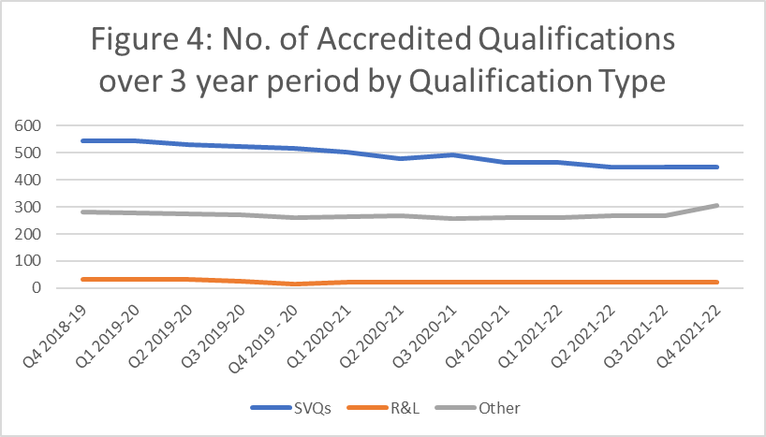
As shown in the graph, the number of qualifications has remained steady overall, and the number of SVQs has decreased by less than 100 in the last three years.

2.1 Total candidate registrations and certifications

2.1.1 Registrations
34,636 candidates were registered for SQA accredited qualifications in Q4.
This is an 0.2% decrease from Q3.

2.1.2 Certifications
26,132 certificates were awarded for SQA accredited qualifications in Q4.
This is a 9.9% increase compared to Q4.

2.2 Top ten qualifications
Table 1: Top 10 performing qualifications in terms of registrations
Qualification title | Registrations
NEBOSH National General Certificate in Occupational Health and Safety | 2715
Safecert SCQF Level 6 Award in Emergency First Aid at Work | 1926
Award in Emergency First Aid at Work at SCQF Level 6 | 1676
SVQ in Social Services and Healthcare at SCQF Level 7 | 1005
SVQ in Social Services and Healthcare at SCQF Level 6 | 967
Award in Emergency First Aid at Work at SCQF Level 6 | 904
SVQ in Social Services (Children and Young People) at SCQF Level 7 | 885
Scottish Certificate for Personal Licence Holders at SCQF Level 6 | 793
Scottish Certificate for Personal Licence Holders at SCQF Level 6 | 785
Award in First Aid for Mental Health at SCQF Level 5 | 752

NEBOSH National General Certificate in Occupational Health and Safety had the highest number of registrations in Q4 of 2021–22. Compared to figures from Q3:
- Registrations for this qualification are 23.3% greater.
Table 2: Top 10 performing qualifications in terms of certifications
Qualification title | Certifications
Safecert SCQF Level 6 Award in Emergency First Aid at Work | 1926
Award in Emergency First Aid at Work at SCQF Level 6 | 1670
NEBOSH National General Certificate in Occupational Health and Safety | 1372
Award in Emergency First Aid at Work at SCQF Level 6 | 857
Scottish Certificate for Personal Licence Holders at SCQF Level 6 | 782
Award in First Aid for Mental Health at SCQF Level 5 | 752
Highfield Award in Emergency First Aid at Work at SCQF Level 6 | 728
ITC Certificate in Emergency First Aid at Work at SCQF Level 6 | 685
SVQ in Social Services and Healthcare at SCQF Level 6 | 678
Scottish Certificate for Personal Licence Holders at SCQF Level 6 | 648

Safe Cert SCQF Level 6 Award in Emergency First Aid at Work had the highest number of certifications in Q4 of 2021–22. Compared to figures from Q3:
- Certifications for this qualification are 0.3% lower.

2.3 Registrations and certifications by qualification type
The following figures detail the number of registrations and certifications over a three-year period, broken down by qualification type. As there are peaks and troughs throughout the year for SVQs, it is more appropriate to compare the number of registrations and certifications to the equivalent quarter from the previous year rather than the preceding quarter.
The impact of COVID-19 is evident for all qualification types, as shown by the dip in early 2020–21. However, registrations and certifications have since increased and are now at a level comparable with the pre-pandemic period.

2.3.1 SVQs
- 10,116 registrations
- 6,531 certifications
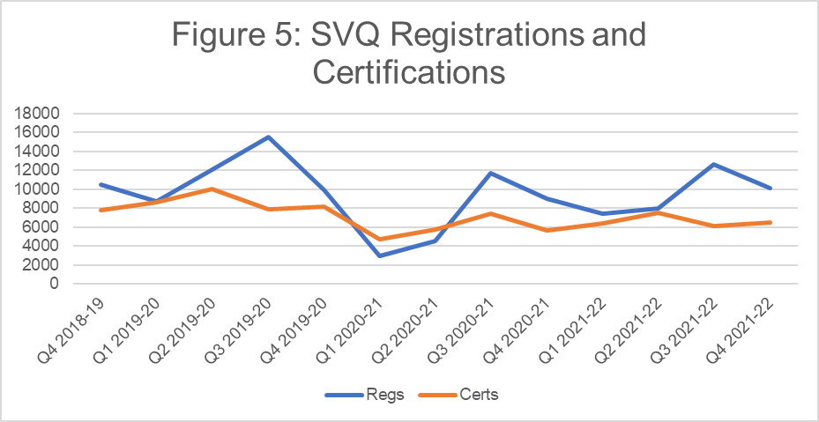
- Compared to Q4 of 2020–21, the number of SVQ registrations has increased by 12.6%.
- Compared to Q4 of 2020–21, the number of SVQ certifications has decreased by 16.5%.

2.3.2 Regulatory & Licensing (R&L)
- 3835 registrations
- 3541 certifications
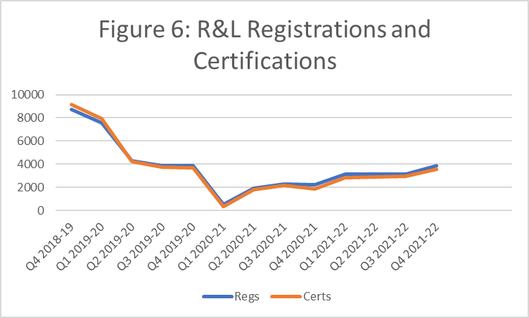

In comparison to Q3 of 2021–22:
- R&L registrations are 22.3% higher in Q4.
- R&L certifications are 19.9% higher in Q4.
The peak in Q4 2018–19 can be attributed to the Scottish Certificate for Personal License Holders (Refresher) qualifications. The Licensing (Scotland) Act 2005 came into full effect in September 2009. A refresher course is required every five years. For the last three quarters, the uptake rate has gradually increased.

2.3.3 ‘Other’ qualifications
- 20,785 registrations
- 16,060 certifications
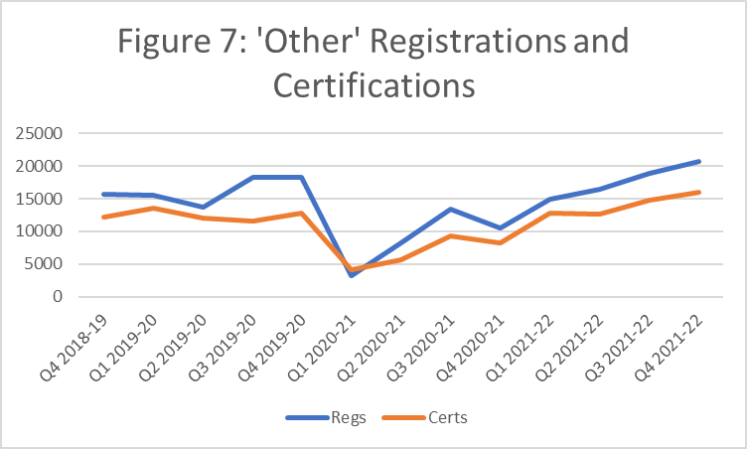

In comparison to Q3 2021–22:
- registrations for other qualifications have increased by 9.3%
- certifications for other qualifications have increased by 9%

2.4 Analysis by awarding body
At the end of the fourth quarter there were 36 awarding bodies approved by SQA Accreditation. The number of qualifications offered by each awarding body varies greatly. The five largest awarding bodies, in terms of qualifications offered, are:
Awarding body | Number of accredited qualifications*
Scottish Qualifications Authority (SQA) | 446
Institute of the Motor Industry (IMI) | 56
City & Guilds | 55
Qualifications for Industry (QFI) | 41
National Examination Board in Occupational Safety and Health (NEBOSH) | 38
*Including qualifications that have passed their lapse dates.

2.4.1 SVQs
SQA continues to have the highest number of SVQ registrations and certifications:
- 89.6% of SVQ registrations
- 85% of SVQ certifications
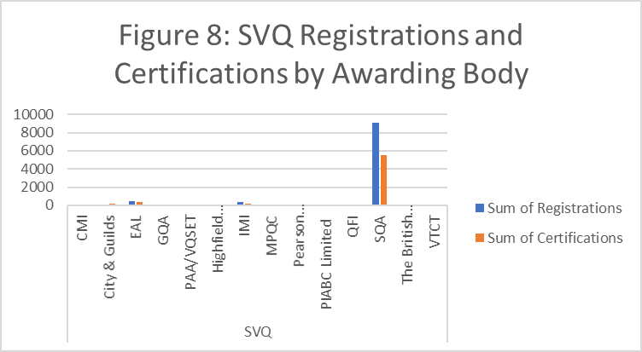

2.4.2 Regulatory and Licensing
Highfield Qualifications accounted for the highest number of R&L registrations certifications:
- 54.2% of registrations
- 55.6% of certifications
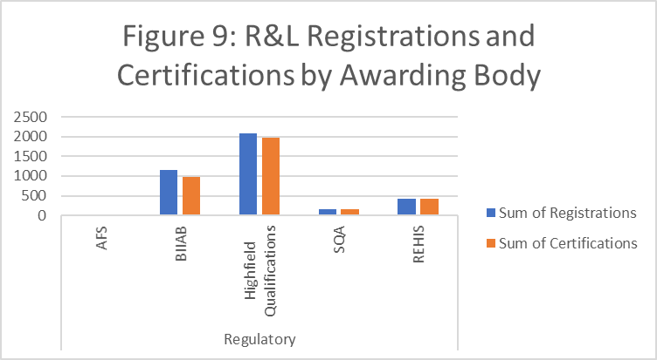

2.4.3 Other’ qualifications
National Examination Board in Occupational Safety and Health (NEBOSH) has the highest number of ‘Other’ registrations:
- 21.2% of ‘Other’ registrations
First Aid Awards Limited (FAA) have the highest number of ‘Other’ certifications:
- 26.2% of ‘Other’ certifications
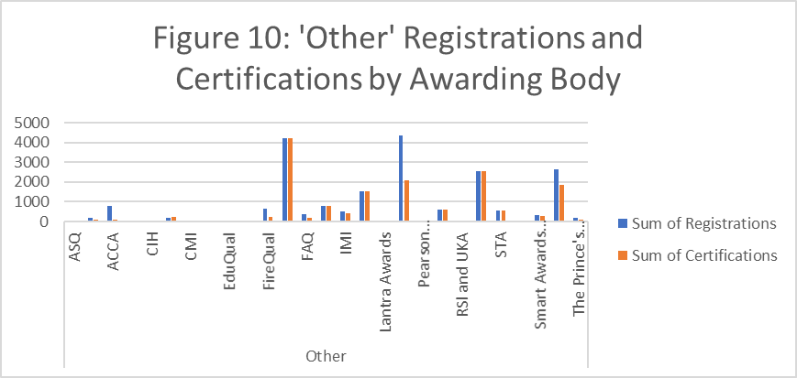

2.5 Analysis by developer
This section compares the registrations and certifications by developer across the three qualification types — SVQs, Regulatory & Licensing, and ‘Other’. The following graph summarises registrations and certifications by developer.
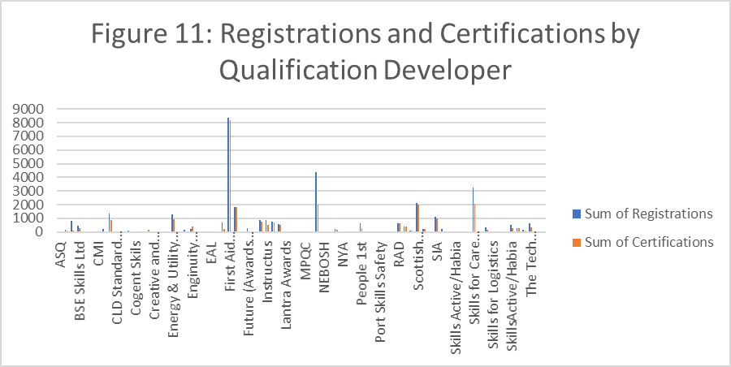
First Aid Awarding Organisation Forum has the highest number of registrations (24.2%) and the highest number of certifications (31.3%).

2.5.1 SVQs
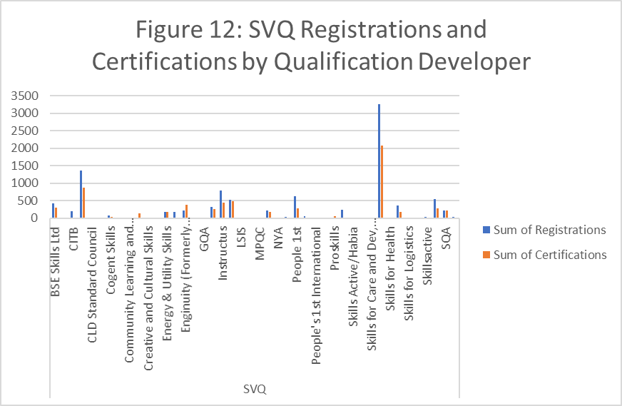
SVQs are favoured across a wide range of developers. Skills for Care and Development account for the largest proportion of SVQ registrations and certifications — 32.2 % and 31.8%, respectively.

2.5.2 Regulatory and Licensing
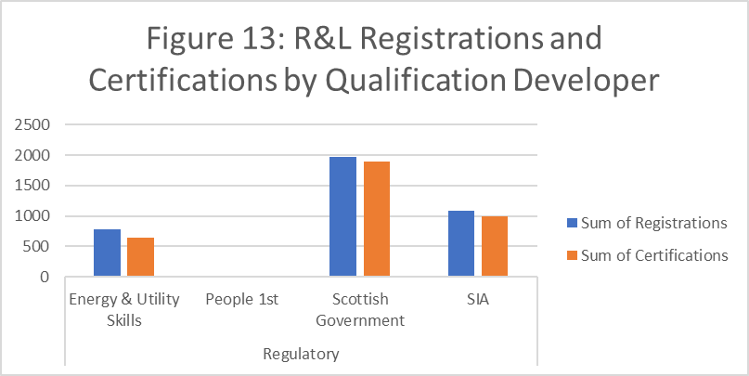

Compared to SVQs, Regulatory & Licensing qualifications are offered by a smaller range of developers and are largely in the Security and First Aid sectors. Scottish Government accounts for the largest proportion of registrations and certifications — 51.2% and 53.7% respectively.

2.5.3 ‘Other’ qualifications
While a wide range of organisations develop ‘Other’ qualifications across different industries, the majority of registrations can be attributed to a small number of developers, and hence a small number of sectors.
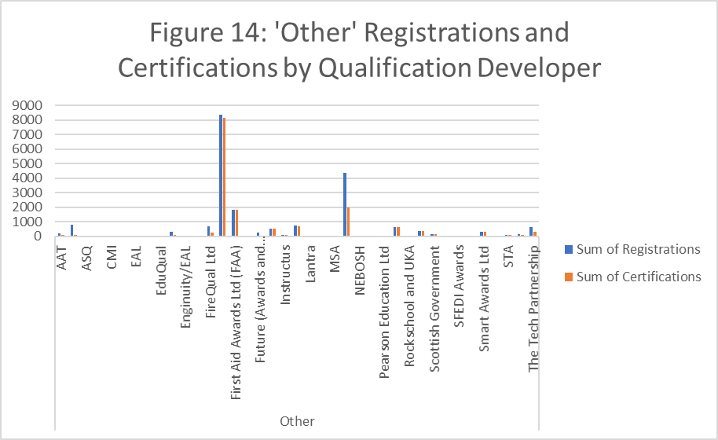
The largest proportion of registrations and certifications in qualifications were developed by First Aid Awarding Organisation Forum; 40.4% of registrations and 50.9% of certifications.

2.6 Analysis by qualification categories
SQA Accreditation assign qualifications to one of the following 16 qualification categories:
- 001 Land-based and Aquaculture
- 002 Business Administration
- 003 Health care, Social care and Childcare
- 004 Protective Services
- 005 Catering, Hospitality and Tourism
- 006 Construction
- 007 Creative and Design
- 008 IT and Digital
- 009 Education and Training
- 010 Engineering and Manufacturing
- 011 Hair and Beauty
- 012 Science and Mathematics
- 013 Retail
- 014 Legal and Financial
- 015 Sports and Active Leisure
- 016 Transport and Logistics
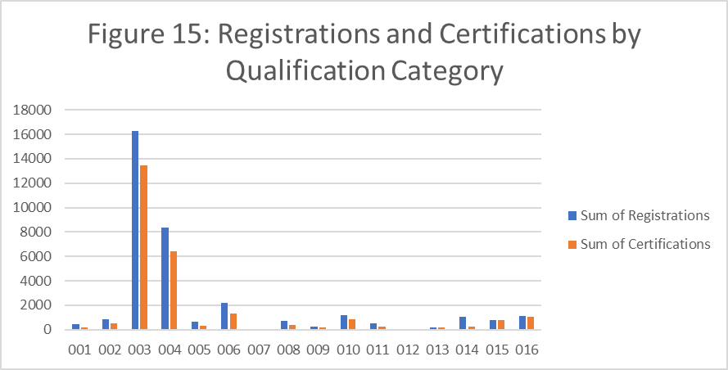
The area with the highest number of registrations and certifications is 003 Health Care, Social Care and Childcare.
- 44% of registrations
- 51.5% of certifications
By qualification type, the qualification categories with the highest number of registrations and certifications are:
Qualification type | Category with highest number of registrations | % of total regs | Category with highest number of certifications | % of total certs
SVQs | 003 | 34.9% | 003 | 34%
Regulatory & Licensing | 004 | 100% | 004 | 100%
Other | 003 | 61.6% | 003 | 70%

3 Workplace Core Skills
Workplace Core Skills are the broad, transferable skills that help to develop the main capabilities people need to be full, active and responsible members of society. Workplace Core Skills were specifically developed to assess Core Skills in a work environment. They contribute to employability and are a component of Modern Apprenticeships in Scotland. Each Workplace Core Skill is available at SCQF levels 3 to 6.
The five Workplace Core Skills are:
- Communication
- Information and Communication Technology (ICT)
- Numeracy
- Problem Solving
- Working with Others
At the end of Q4 2021–22, there were:
- 145 accredited Workplace Core Skills
- 8787 registrations (a decrease of 3.2% compared to Q3)
- 6597 certifications (an increase of 14.9% compared to Q3)
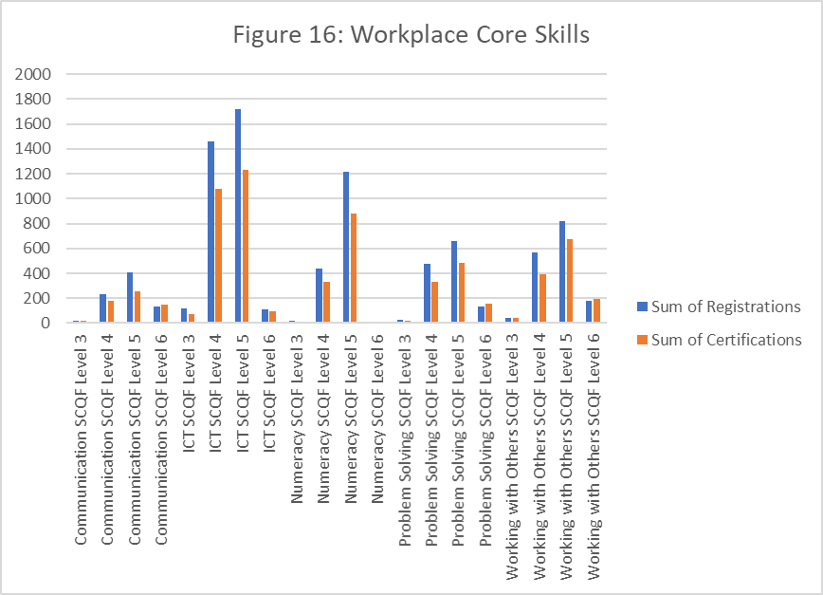

Workplace Core Skills are offered by seven awarding bodies.

Awarding body | Registrations | Certifications
City & Guilds | 0 | 441
Excellence, Achievement & Learning Ltd (EAL) | 111 | 114
Institute of the Motor Industry (IMI) | 1516 | 436
Pearson Education Limited | 159 | 109
Qualifications for Industry (QFI) | 0 | 18
Scottish Qualifications Authority (SQA) | 6945 | 5469
Vocational Training Charitable Trust (VTCT) | 56 | 10
Grand Total | 8787 | 6597
*City & Guilds registers candidates for Workplace Core Skills on a one-to-many basis using its internal Programme of Study number (PoS), therefore it is not possible at this time to generate registration figures for each Core Skill.
SQA continues to have the highest registrations and certifications for Workplace Core Skills:
- 79% of registrations
- 82.9% of certifications

https://accreditation.sqa.org.uk/accreditation/Research_and_Statistics/Data_Collection_Requirements _and_Guidance
https://accreditation.sqa.org.uk/accreditation/accreditationfiles/About_Us/20210412_Methodology.pdf

